TASK 1 – ALU

[**Digital Circuits**](https://vlsiweb.com/category/digital-design/digital-circuits/)

**Arithmetic Logic Unit in Digital Circuits**

[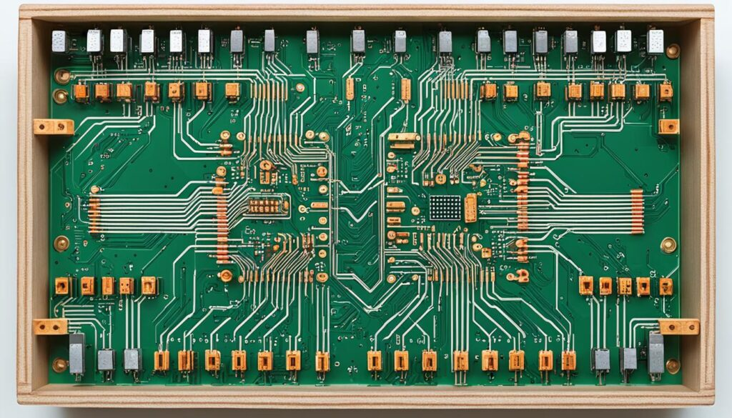](https://vlsiweb.com/wp-content/uploads/2024/04/Arithmetic-Logic-Unit.jpg)

In the intricate world of digital circuit design, the arithmetic logic unit (ALU) stands as an indispensable pillar. Integral to the computational fortitude of modern processors, the ALU’s ability to perform arithmetic and logical operations on a plethora of operands furthers our journey into understanding how data is manipulated at the most fundamental level. We delve into the role of ALU and its importance as the calculating nucleus of the central processing unit (CPU), driving the very heart of our digital devices.

Our focus is to elucidate the capabilities that allow an ALU to handle both simple and complex instructions that are vital for executing the myriad tasks demanded by today’s software. As we chart the nuances of digital circuit design, we recognize that the ALU is not just a component but a beacon of innovation that continuously shapes the efficiency and power of computing technology.

Table of Contents

* [Understanding the Arithmetic Logic Unit and Its Functionality](https://vlsiweb.com/arithmetic-logic-unit/)
  + [Core Components of the ALU: Arithmetic and Logic Units](https://vlsiweb.com/arithmetic-logic-unit/)
  + [How the ALU Performs Basic and Complex Operations](https://vlsiweb.com/arithmetic-logic-unit/)
  + [Representation of Data in ALU Processing](https://vlsiweb.com/arithmetic-logic-unit/)
* [The Evolution of ALUs in Digital Circuit History](https://vlsiweb.com/arithmetic-logic-unit/)
* [Arithmetic Logic Unit: The Brain Behind CPU Calculations](https://vlsiweb.com/arithmetic-logic-unit/)
* [Key Operations and Algorithms Powered by the ALU](https://vlsiweb.com/arithmetic-logic-unit/)
  + [Binary Arithmetic Processes: Addition, Subtraction, Multiplication, and Division](https://vlsiweb.com/arithmetic-logic-unit/)
  + [ALU Logic Operations: AND, OR, XOR, and More](https://vlsiweb.com/arithmetic-logic-unit/)
  + [Effect of ALU Operations on Processor Performance](https://vlsiweb.com/arithmetic-logic-unit/)

**Understanding the Arithmetic Logic Unit and Its Functionality**

Delving deep into the infrastructure of modern computing, we acknowledge the arithmetic logic unit’s pivotal role in data processing and execution of algorithms. The ALU stands as the quintessential element that navigates the complex network of computations within a computer’s central nervous system. Now, let’s dissect the sophisticated architecture and meticulous functionalities of an ALU that underline its indispensability in computational tasks.

**Core Components of the ALU: Arithmetic and Logic Units**

Central to the arithmetic logic unit functionality is its division into two primary ALU components: the arithmetic unit (AU) and the logic unit (LU). The AU is designed to handle operations of mathematical nature, such as addition, subtraction, multiplication, and division. Meanwhile, the logic unit addresses operations like AND, OR, and XOR. It is this synergy of ALU components which enables the execution of an extensive array of tasks.

**How the ALU Performs Basic and Complex Operations**

In intricate digital environments, the ALU operations begin as soon as instruction codes are funneled into the system, pinpointing the specific operations to manifest on the given operands. Whether it’s executing a simple add or a subtract command, or engaging in complex comparison protocols for decision-making, the ALU stands at the ready, adeptly translating code into tangible outputs.

**Representation of Data in ALU Processing**

Understanding data representation in ALU is critical to fathom how this brain of the computer functions. Binary numbers lay the foundation as the universal language through which the ALU communicates. Regardless of whether the operation is binary arithmetic for actions such as multiplication or division, or logical for bit manipulations, it is binary digits that are artistically woven into desired outcomes.

|  |  |  |  |
| --- | --- | --- | --- |
| **Operation Type** | **Binary Representation** | **ALU Components Involved** | **Examples** |
| Arithmetic | 010101 + 101101 | Arithmetic Unit (AU) | Addition, Subtraction |
| Logical | 0101 AND 1010 | Logic Unit (LU) | AND, OR, XOR |
| Complex | Represented in combined binary operations | AU and LU | Comparisons, Multiplexing |

In conclusion, navigating through the complexity and precision of the arithmetic logic unit functionality, we gain insight into the meticulous orchestration of ALU operations. It’s a testament to engineering genius that allows for simple and complex calculations to be executed with remarkable speed and efficiency. As we explore the realms of computing, the ALU continues to be an unparalleled component, meticulously choreographing the flow of binary data representation in countless applications.

**The Evolution of ALUs in Digital Circuit History**

As we delve into the **digital circuit history**, it’s clear that the **evolution of ALUs** has been monumental, marking a transformative journey from basic computing elements to sophisticated processors. The **historical development of ALU** technology reflects a series of innovations that have significantly enhanced computational capabilities.

In the nascent phase of computing, ALUs were elementary units capable of managing only the simplest of arithmetic and logical functions, often taking multiple cycles for a single instruction. As the demand for faster and more efficient computation grew, so did the sophistication of these integral units. This helped pave the way for the single-chip microprocessors of the 1970s, where ALUs became central to the processing power of computers.

The subsequent **advancements in ALU technology** have been tied to the rapid growth in transistor density, following Moore’s Law. With the advent of very large-scale integration (VLSI) technologies, ALUs were able to handle increasingly large word sizes and perform more complex operations swiftly and accurately.

1. Early computer models with simple ALUs.
2. Introduction of microprocessors integrating more capable ALUs.
3. Advancements in VLSI technologies enabling higher performance.

Today, ALUs are embedded in the fabric of CPUs and GPUs, playing a pivotal role in executing a wide array of operations in just a single clock cycle, a far cry from their humble beginnings. It is these incremental but impactful strides in ALU design that have continuously reshaped the landscape of digital computing and processing power.

Historical development of ALU

Our understanding of these technologies has not only allowed us to appreciate the **historical development of ALU**, but also to anticipate the future trajectory of digital processing. As we forge ahead, the ongoing **evolution of ALUs** promises even greater efficiencies, spearheading the next generation of digital circuitry and computing paradigms.

**Arithmetic Logic Unit: The Brain Behind CPU Calculations**

At the core of every computer’s processing capability lies the arithmetic logic unit in CPU, a vital component that performs ALU calculations, ensuring the smooth execution of programs. As an essential CPU component, the ALU interprets data from CPU registers and executes operations through intricate electronic circuitry.

The robust functioning of ALU as CPU component allows computers to conduct a broad spectrum of tasks, from the simplest arithmetic operations to complex logical ones. It’s the precision and efficiency of an ALU that determine the speed at which a CPU performs, affecting everything from computing to gaming, and from data analysis to application running.

Arithmetic Logic Unit in CPU

The depth of ALU calculations can be quite extensive. Below, we elucidate some of the ALU’s fundamental capabilities, which together contribute to the formidable processing power of modern CPUs:

* Arithmetic computations such as addition, subtraction, multiplication, and division.
* Logical operations including AND, OR, XOR, NOT, and comparison functions.
* Shift and rotate functions that adjust bit positions which are critical in data processing tasks.

To give a clearer idea of how the ALU functions as a decisive CPU component, consider the following table, which highlights typical ALU operations and their influence on CPU output:

|  |  |  |
| --- | --- | --- |
| **Operation Type** | **Description** | **Impact on CPU Performance** |
| Arithmetic Operations | Performs basic calculations that form the basis of more complex computational tasks. | Directly affects the CPU’s ability to handle computational tasks efficiently. |
| Logical Operations | Handles all forms of binary logic processes crucial for decision-making algorithms. | Improves the CPU’s capacity to make logical decisions and execute condition-based operations swiftly. |
| Shift Operations | Manipulates bit positions, essential for tasks such as encryption, encoding, and graphic processing. | Enhances the CPU’s handling of specialized tasks, which can result in higher performance in specific applications. |

Understanding the arithmetic logic unit in CPU is key to appreciating the technological advancements and computational power of modern electronics. ALU calculations not only amplify the execution of programs but also warrant attention when one considers the future of processing units and what they will be capable of achieving. Indeed, the ALU remains a cornerstone component, ensuring that CPUs meet the growing demand for faster and more efficient computation.

**Key Operations and Algorithms Powered by the ALU**

The engine driving computational efficiency in modern processors is undoubtedly the Arithmetic Logic Unit (ALU). Its intricate and central role in computer architecture cannot be overstated. By harnessing the dual capabilities of binary arithmetic and logic operations, ALUs facilitate a myriad of processes that scale from simple calculations to the execution of complex algorithms, directly influencing processor performance. Through our exploration, we’ll delve into how ALUs perform these critical tasks and the overarching impact on computing systems.

**Binary Arithmetic Processes: Addition, Subtraction, Multiplication, and Division**

Binary arithmetic is the bedrock upon which computing systems operate. Each ALU operation, whether an addition, subtraction, multiplication, or division, plays a critical part in data processing and algorithm execution. Leveraging binary arithmetic, these ALU operations are skillfully orchestrated to resolve myriad tasks, from the most straightforward arithmetic to the underpinning of intricate ALU algorithms. The ability to execute these operations with unwavering precision is a testament to the advanced architecture of modern ALUs.

**ALU Logic Operations: AND, OR, XOR, and More**

Logic operations are as fundamental to computing as arithmetic ones. ALUs leverage operations such as AND, OR, XOR, NOT, and NOR to execute control procedures, data comparison, and boolean logic. These elemental logic operations enable computers to make decisions and carry out instructions based on logical conditions, crucial for the inner workings of complex computing systems.

**Effect of ALU Operations on Processor Performance**

Every increment in speed and efficiency in ALU operations can have a significant impact on the overall processor performance. The efficiency of ALU algorithms contributes to greater computational speeds, allowing for faster and more accurate processing of tasks. As a result, innovations aimed at optimizing ALU operations are continuously pursued to elevate the capabilities of processors, thus delivering swifter and more robust systems for users worldwide.

|  |  |  |
| --- | --- | --- |
| **Operation Type** | **Function** | **Impact on Processor Performance** |
| Binary Arithmetic | Addition, Subtraction, Multiplication, Division | Directly influences computational speed and efficiency |
| Logic Operations | AND, OR, XOR | Enables decision-making and controls based on logical conditions |

Our engagement with the myriad operations of the Arithmetic Logic Unit reveals the remarkable versatility and power of this processor cornerstone. By facilitating both binary arithmetic and logic operations, the ALU remains an essential factor in advancing ALU algorithms and enhancing processor performance, marking its critical presence in the ongoing evolution of computing technology.

**Conclusion**

As we reflect on the pivotal role of the arithmetic logic unit (ALU), we recognize its profound impact on the field of digital circuit design. The ALU is indeed the cornerstone that ensures CPUs can perform the necessary arithmetic and logical computations required for complex data processing. Through the various advancements in ALU technology, we’ve observed how it has continuously elevated processor performance, embodying the essence of innovation in computing.

In delving into the significance of ALU in digital circuit design, it’s paramount to acknowledge that the efficiency and effectiveness of modern computing systems largely hinge upon the intricate workings of this sophisticated component. Each leap in its capabilities has fostered the growth and acceleration of digital advancements. In essence, our discussion concludes that the ALU is not only a fundamental component but also a driver of relentless progress in the computing world.

As the landscape of technology evolves, the future shines bright for further enhancements of ALU design, promising even faster and more efficient processing power. This, in turn, strengthens our resolve to continue exploring and contributing to this dynamic field where the ALU remains at the heart of digital circuit innovation. The conclusion about ALU — its evolution, application, and boundless potential — cements its stature as an architectural marvel in the tapestry of computational design.

